Gerald Griffin, President
Jerry Deal, Vice President
BON AQUA-LYLES UTILITY DISTRICT
P.O. BOX 35
LYLES, TENNESSEE 37098 (931) 670-3957

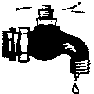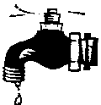Mike Capps, Sect. Treasurer
Brad Barnes, Manager

e-mail: bonaqualylesutility@yahoo.com
website: bal-ud.com

Termination of Water Services

Date _________________________________

Name _________________________________ Account # _________________________________

_________________________________

_________________________________

Terminate Water Services at the above address on date _________________________________

FINAL Bill Address _________________________________

_________________________________

_________________________________

Phone Number _________________________________

Last 4 digits of Social _________________________________

The final bill is usage from _________________________________ to _________________________________

_________________________________
Customer Signature

_________________________________
BALUD

